Project 1 Homework requested screenshots

Docker ps

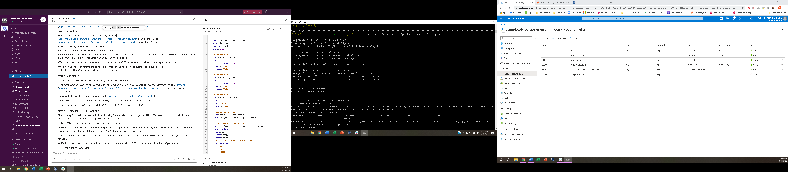

Kibana

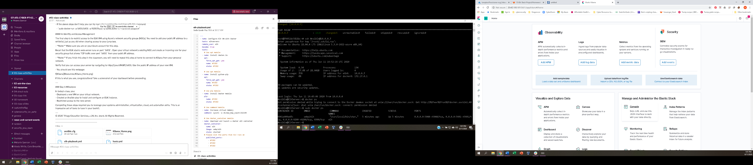

Data received

File beat

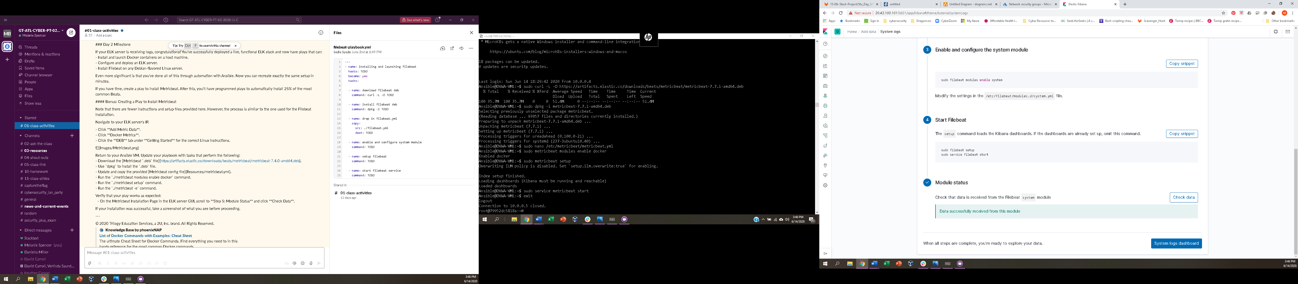

metricbeat

